## INTRODUCTION

* 1. Overview

Over 70% of the Indian population practices agriculture. Hence, the production and management of crops is an important aspect to ensure optimal productivity in the fields. Agriculture yield data is used to analyze and improve the crop yield and represent in

the form of a Graphs through data visualization technique. The visualization methods presented include interactive charts to enable our data users to drill down and focus on more detailed views of these data displays. Each of these methods facilitates the display of large volumes of data and allows data users to extract information from our statistics that is difficult or impossible to obtain from traditional

static charts or tabular displays of data. Visual representations, readers can gain valuable insights into crop production, seasonal variations, regional distribution, and overall production trends.

* 1. purpose
     + This project helps farmers in providing the historical crop yield record with a forecast reducing the risk management.
     + The visualization can help government agencies develop policies that support agriculture. This type of graphs can help government agencies better support the needs of farmers and the agricultural industry.
     + Crop yield visualization can then inform import/export decisions as well as price structure, crop distribution, and future crop

.

1. **Problem Definition & Design Thinking**
   1. Empathy Map

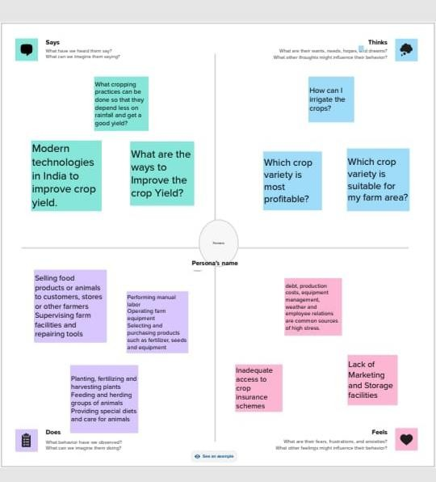

* 1. Ideation & Brainstorming Map

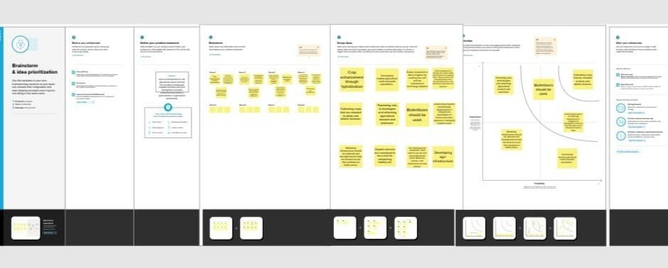

3 Result

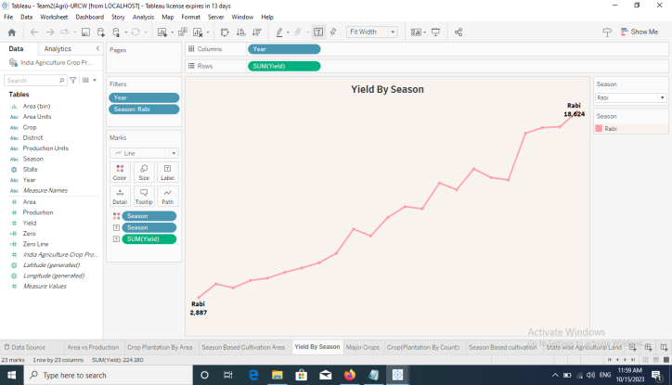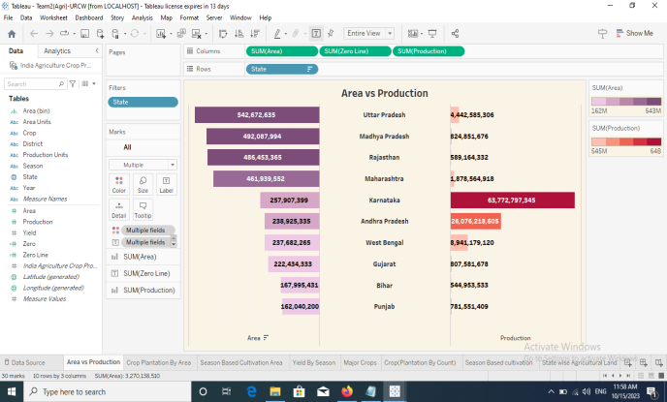

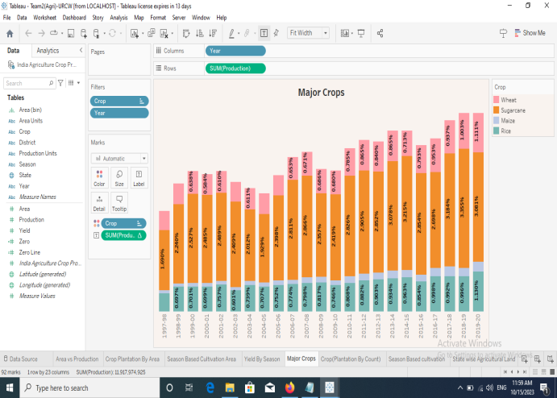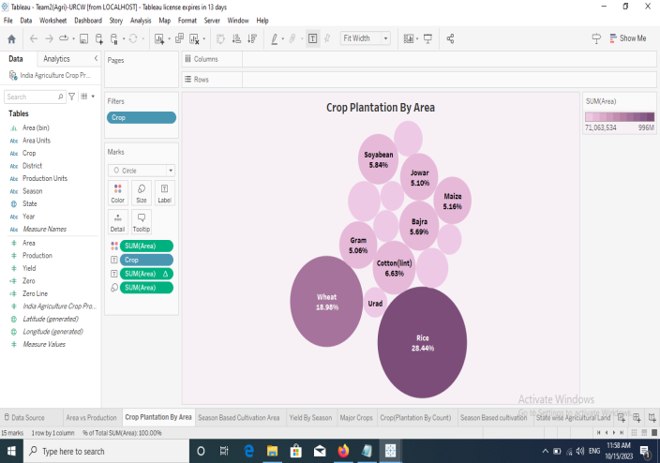

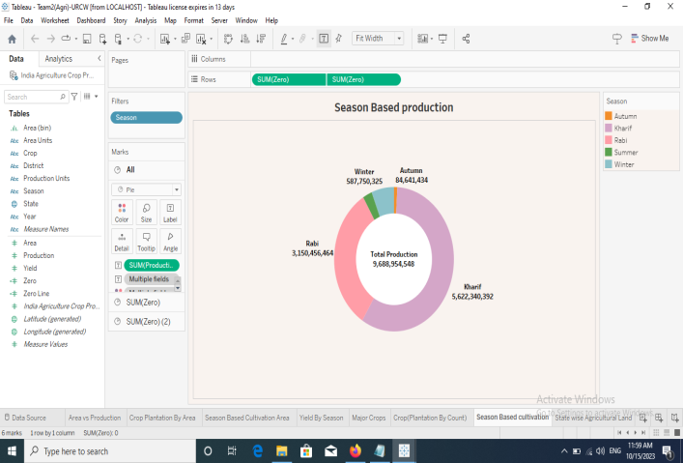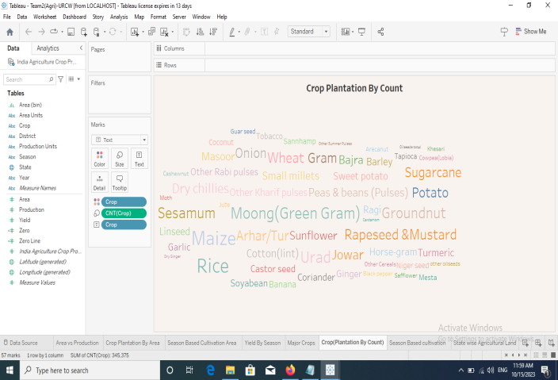

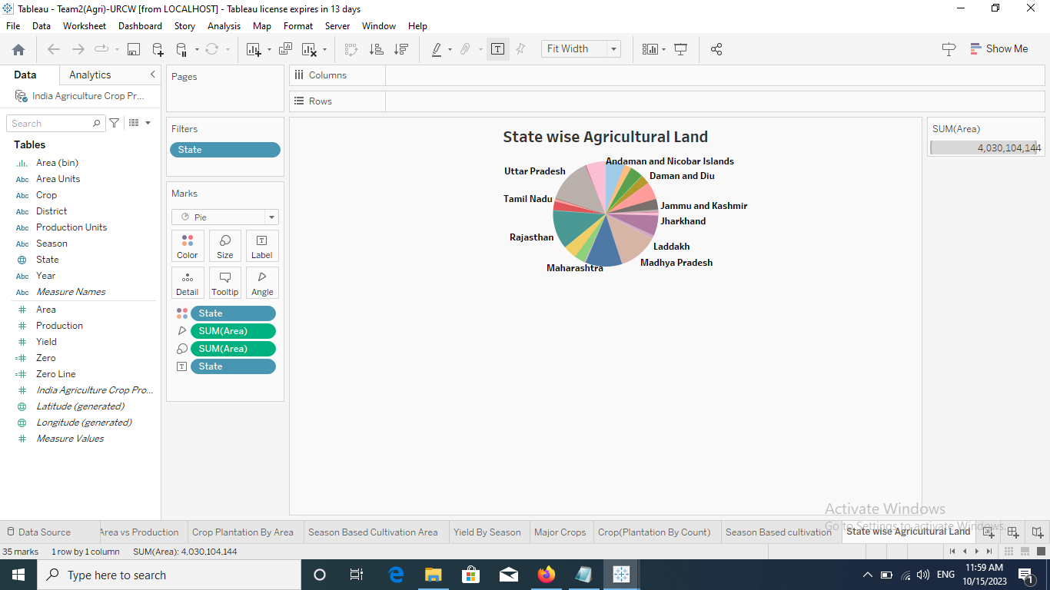

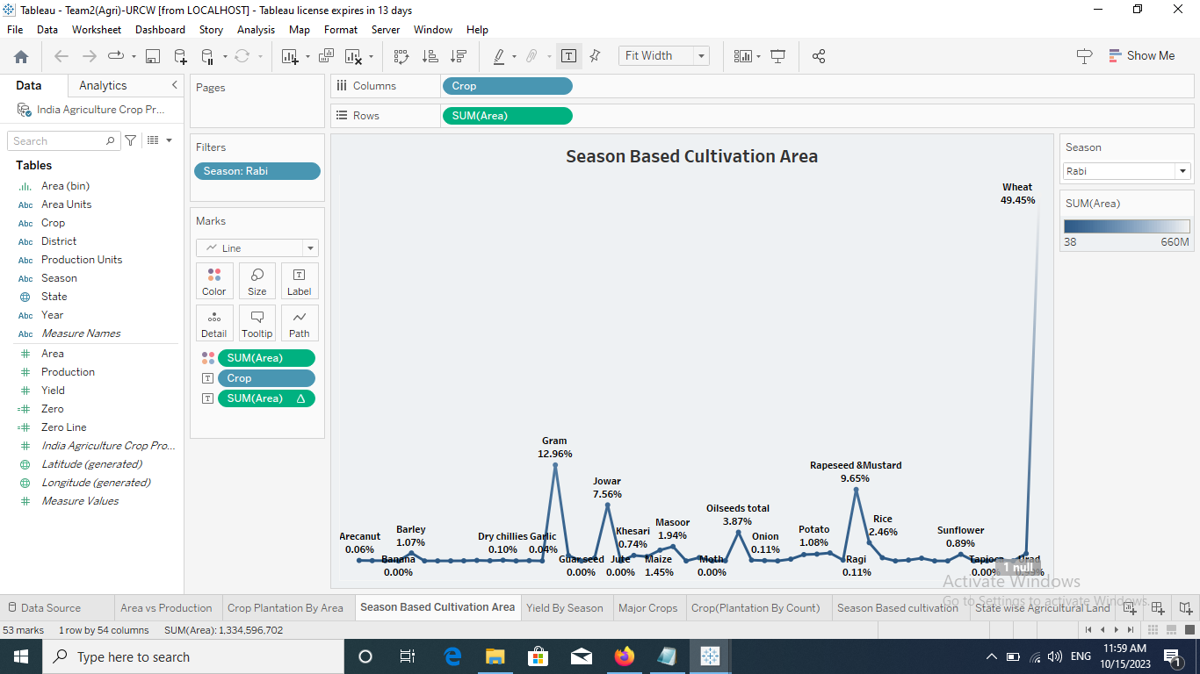

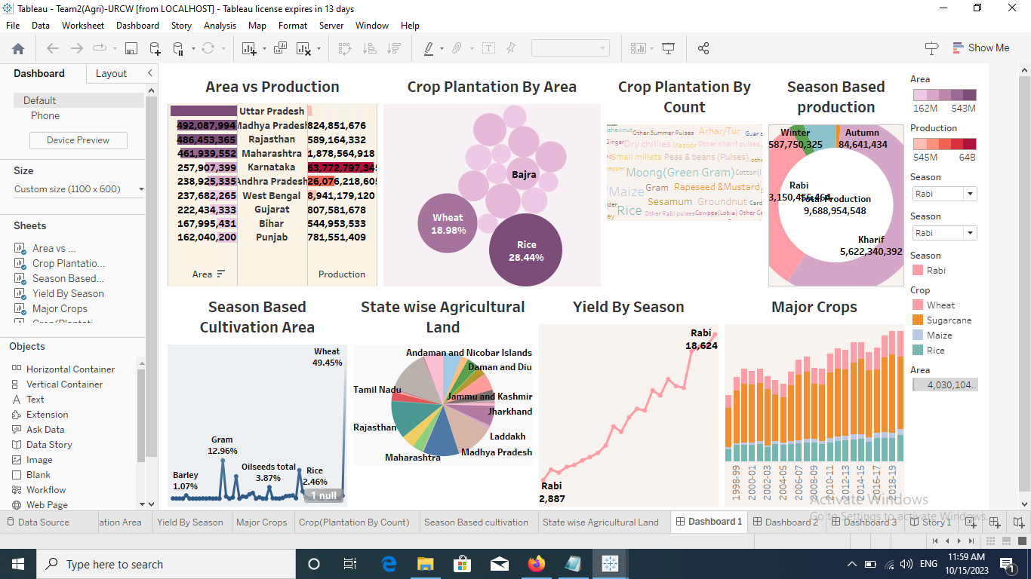

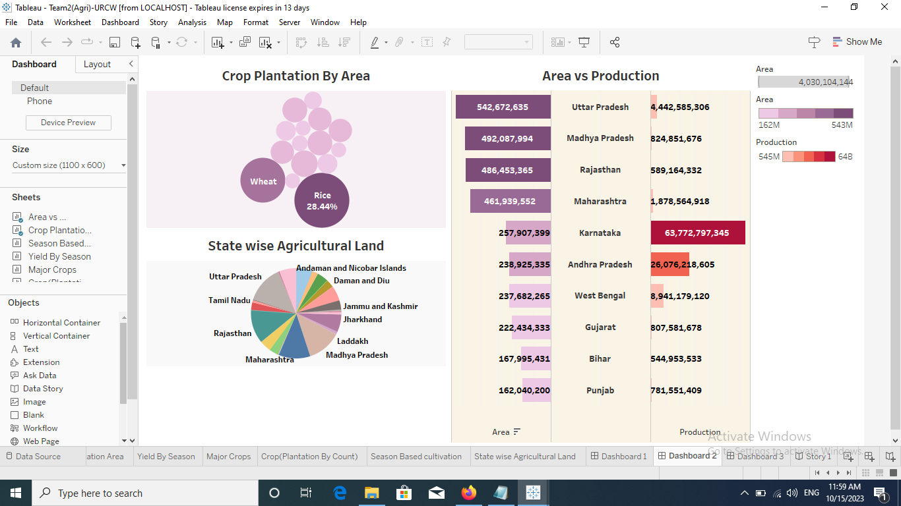



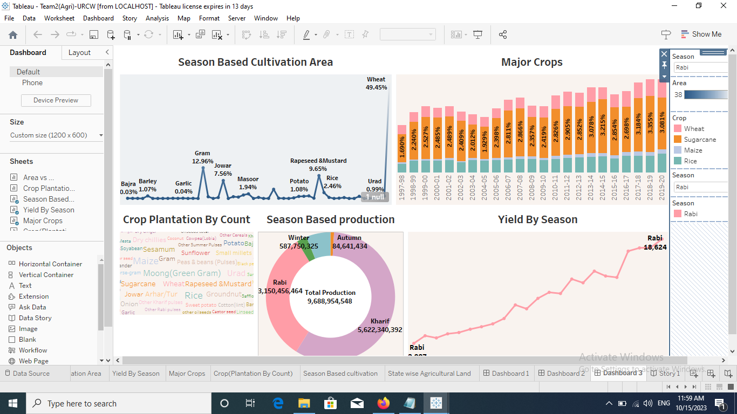

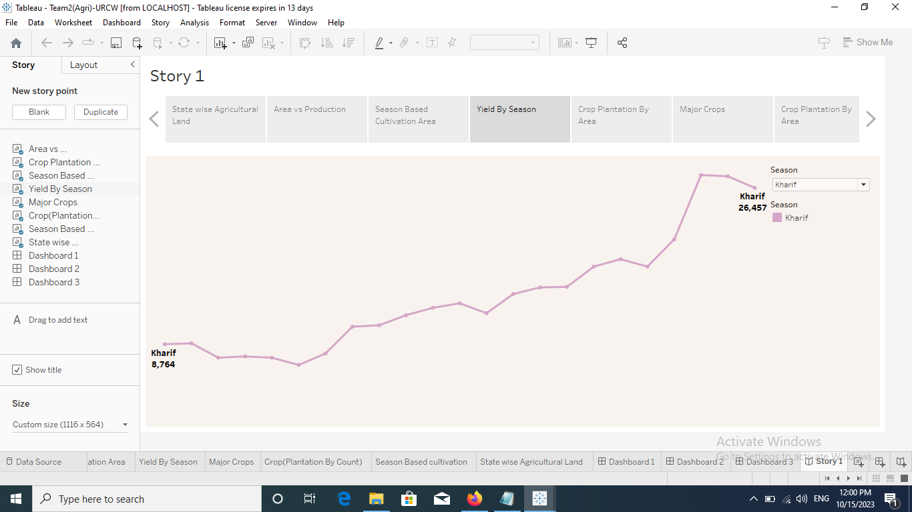

## ADVANTAGES & DISADVANTAGES

The use of modern technologies in farming has brought both advantages and disadvantages. That are listed below.

* Increased crop yield as work can be done faster and more efficiently.
* Increased profit for the farmer
* Less physical work for people
* Crops are harvested faster so they are fresher
* Fewer workers so less wages for farmer to pay
* Loss of animal habitats and shelter belts, as hedgerows were removed to increase field size, and accommodate large machinery
* Increase in noise pollution
* Fewer jobs available
* As people become unemployed they move away to find work,

leading to rural depopulation

* Machines are expensive to buy and repairs can be costly.

1. **APPLICATIONS**

# New concept refers to the use of technology in farming and agricultural practices to increase efficiency, productivity, and sustainability in food production. It includes several different types of technologies, such as precision agriculture, smart irrigation, biotechnology, and automation.

* Indoor vertical farming can increase crop yields, overcome limited land area, and even reduce farming’s impact on the environment by cutting down the distance traveled in the supply chain.

# The traditional livestock industry is a sector that is arguably the most important yet widely overlooked sector, as it provides much-needed renewable natural resources that we rely on every day.

## CONCLUSION

* This survey aims at promoting smart farming mechanisms by prescribing possible crops by incorporating statistical data visualization techniques. This would help famers plan their cultivation in a viable manner based on the regional parameters.
* This promotes prescriptive crop cultivation based on smart farming and digital analysis methods. The key role of this project is to promote more success rates of cultivation and prevent losses arising from unplanned cultivation while also benefiting the farmer with commercial profits.

## FUTURE SCOPE

Agriculture sector have an enormous scope in India as of the future refrence because agriculture sector is the largest sector with 49% of country's population works in Agriculture sector by occupation. India is also a developing country with about 16% of its GDP is contributed by this sector.

* FARM AUTOMATION

Automation is already a major part of the farming process, but it will become even more important in the coming years. Farmers are already using drones to monitor their crops, and advanced sensors can tell them exactly when they need to water or fertilize their fields.

These devices can also be used to monitor soil quality and ensure that crops aren’t affected by drought or other environmental factors. The increased level of automation will allow farmers to focus more on other aspects of their business than traditional manual labor tasks like watering, seeding, and harvesting

* AI/ML & DATA SCIENCE IN AGRICULTURE TECHNOLOGY

Agricultural forecasting is made easy when farmers deploy AI/ML & data science technology. The use of 3D laser scanning and spectral imaging/spectral analysis, for example, can help farmers predict weather scenarios and optimize the use of resources required for irrigation, fertilization, and pest control.

Through AI/ML & data science technology, farmers can analyze their fields for the best locations for planting seeds. They can use computer vision to recognize plants’ optimal height, width, and spacing. This data can then be used to optimize their growing methods.

* AGRICULTURAL ROBOTICS

In 2022, the global market size of agricultural robotics was nearly $5 billion. The need to meet the increasing global food demand is one of the major driving forces for the wide application and adoption of agriculture robotics.

Many farming activities performed by humans can now be done by agricultural robots (agribots), maximizing productivity and saving enormous resources. Today, agri robots are used In seed planting, crop harvesting, weeding, sorting and packaging, livestock management, etc

* Today's technology paving the way for tomorrow's harvest.

The agriculture ecosystem is fast in embracing technology, and its fullest potential is yet to be discovered. Over the past five decades, digitization has resulted in the radical transformation of agriculture by improving its speed, scale, and productivity globally. Agriculture 4.0, the fourth agricultural revolution, has provided the agri-stakeholders with a broad range of technological options to choose from to help them achieve their goals — be it remote sensing and GPS technologies, artificial intelligence and machine learning, connected sensors, IoTs, or any of the other emerging technologies. Mounting pressures on the environment are also redirecting scientists’ approach to the way we farm today. The road to sustainable farming requires significant investments in infrastructure and technology infusion, but its success can ensure that the current and future generations can live comfortably with the resources available.

## APPENDIX

A. Source Code



<https://public.tableau.com/views/Team2Agri-URCW/Dashboard1?:language=en-US&publish=yes&:display_count=n&:origin=viz_share_link>

<https://public.tableau.com/views/Team2Agri-URCW/Dashboard2?:language=en-US&publish=yes&:display_count=n&:orig>

<https://public.tableau.com/views/Team2Agri-URCW/Dashboard3?:language=en-US&publish=yes&:display_count=n&:orig>

[https://public.tableau.com/views/Team2Agri-URCW/Story1?:language=en-US&publish=yes&:display_count=n&:origin=viz_share_link](C:\\Users\\admin\\Documents\\link)